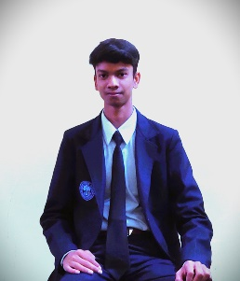
Rishi Prasad Maurya
Mobile No: 9305769696
Email: automationrishiald@gmail.com

CAREER OBJECTIVE
To be a part of an organization where I can effectively contribute my knowledge and enhance my skill to meet company goals.

EDUCATION
Qualification | Board/University | Institution  Name | Year of Passing | Percentage Secured
BCA  (Pursuing) | State University | Shambhunath College of Education | 2023 | 76%
Intermediate | Central Board of Secondary Education | Maharishi Vidya Mandir Shahdol Madhya Pradesh | 2021 | 85%
High School | Central Board of Secondary Education | Oasis Sainik School Hanumangarh Rajasthan | 2019 | 75%

TECHNICAL SKILLS
- YouTube (Search Engine Optimisation)
- C,C++,JAVA
- HTML,CSS
____________________________________________________

COMPUTER SKILL
- MS Power Point,MS Word
- Driver Management
____________________________________________________
EXTRACURRICULAR ACTIVITIES
- Editing Template,LOGO Designing,Banner designing

FIRST LOGO (Gaming Logo)
- Participated in Skating Puzzle Solving Competition Organized by School.
ACHEIVEMENTS
- I Designed a website based on HTML,PHP,CSS in Year 2020.
- We Won a Gaming Tuornament of half Lakh(that why I want to became Game Developer having much interest in Gaming Field.

HOBBIES
- Playing Basketball
- Skating ,Swimming
- Puzzle Solving
- Inspiring People

STRENGTH
- Having a peace (control ) Brain sense
- Determination & obsession towards My goal
- Self Dependent (never depending or trusting other maintaining limit of anything)
____________________________________________________
PERSONALS DETAIL
- Father Name-Shripati Maurya
- DOB-24 june 2003
- Nationality-Hindi
- Martial Status-Single
- Language Known-English ,haryanvi ,Rajasthani
- Address -Sarai Daud Urf Dhakpura,Mailahan,Phulpur,Allahabad.

DECLARATION I hereby declare that the above mentioned details are true to
the best of my knowledge

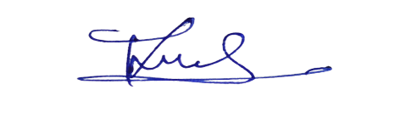
Date: 23 November 2022 RISHI PRASAD MAURYA
Place:Shambhunathe College of
Education Jhalwa Prayagraj

